Ticket Booking

Requirement 1. Ticket Booking On IRCTC Site

prerequisites

1. URl : “https://www.irctc.co.in/nget/train-search”
2. User Account on irctc portal

Step 1 : Click on login button on irctc home page

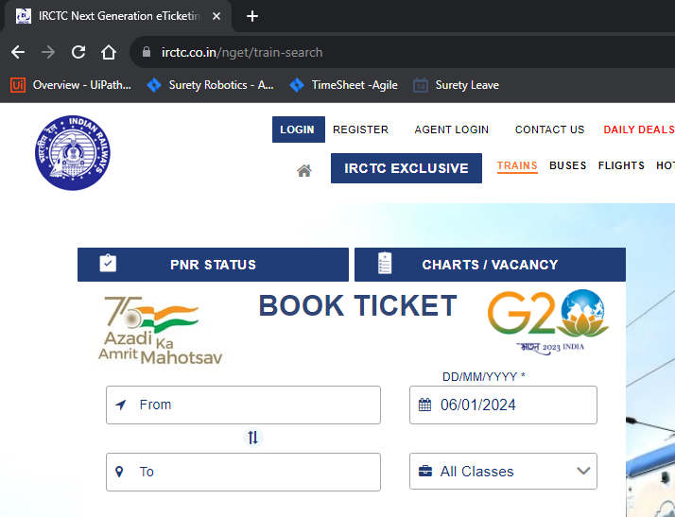

Step 2 : Enter User name and password on login page .

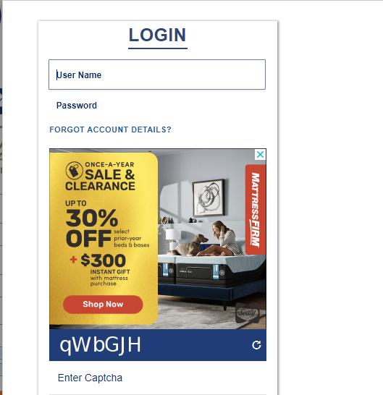

Step 3 : Enter captcha according to irctc page.

Note : Handle captcha as per irctc login rule.

Step 4 : click on sing in button on login page.

Exception : stop the process if unable to login into irctc site with error description “unable to login”.

Step 5 : Click on Add/Modify Master List inside My Profile Section Inside My Account.

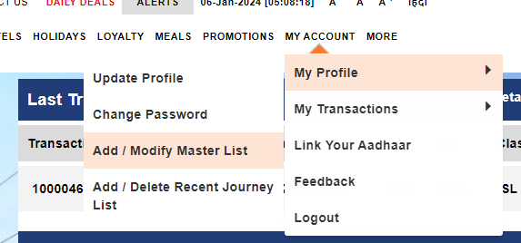

Step 6: Add Master List

1. Select passenger type as “normal”.
2. Enter passenger name.
3. Enter DOB.
4. Enter gender.
5. Select birth preference as “No Choice”.
6. Select catering service as “ veg”
7. Click on submit.

Exception : If passenger name is already add into master list then no need to add it again.

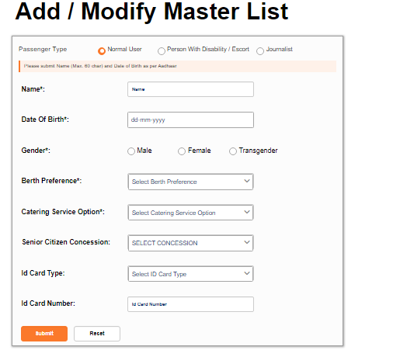

Step 7: Click on book ticket inside trains section.

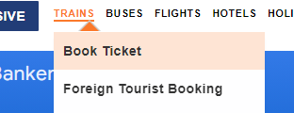

Step 8: Enter journey details

1. Enter boarding details inside From field.
2. Enter destination details inside To field.
3. Enter date of journey in DD/MM/yyyy format.
4. Select journey type as “general”.
5. Click on search.

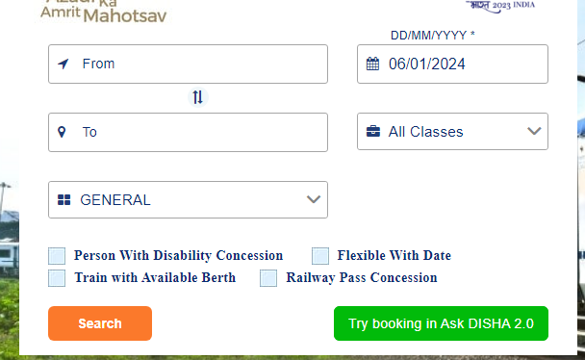

Step 9: select the 1st available train and book the ticket.

1. Select 1st available train.
2. Select class as “SL”.
3. Click on book now.

Step 10: click on “yes” inside conformation pop up if visible on screen.

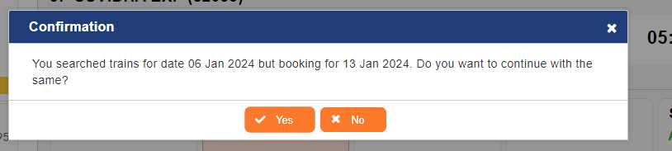

Step 11: Select the passenger name from master list.

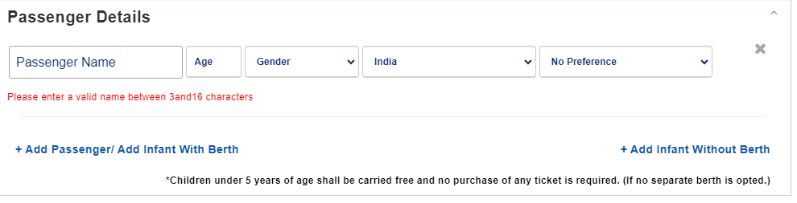

Step 12: Add contact details, Reservation choice, travel insurance as “yes” and select payment method as “pay through Credit & Debit Cards / Net Banking / Wallets / Bharat QR / Pay on Delivery/ Rewards and Others”.

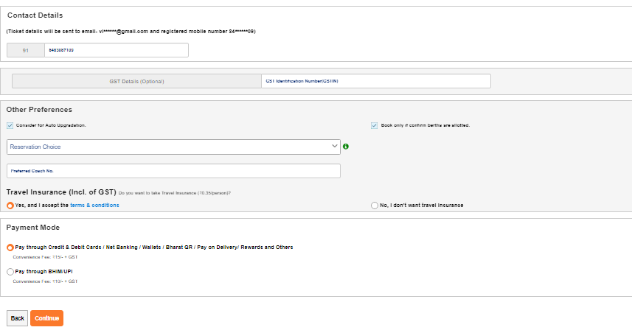

Step13: Click on continue.

Step14:Enter Captcha.



Step15: Click on continue.

Note : Handle All the exception from development side if you found while developing the process.